Title What is an architect?
Overview After viewing, Dancing House, students discuss art-related careers. Students explore the life and work of Frank Gehry, one of the most famous architects of twentieth century America. Using Wallpaper sample books, students will cut out geometric shapes to design a building or house.

Standard Historical and Cultural Perspective

Arts Benchmark
Recognize professions in the visual arts and the role and status of the artist in various cultures and time periods. | VA-HP-E5

Foundation Skills Problem Solving, Linking and Generating Knowledge

Student Understandings

Students demonstrate an understanding of the importance of the arts in contemporary society. They develop an appreciation of arts-related careers and the economic and cultural value each brings to communities.

Grade-Level Expectations (GLEs)
Grade 1 | Mathematics
26. | Compare, contrast, name, and describe attributes (e.g., corner, side, straight, curved, number of sides) of shapes using concrete models [circle, rectangle (including square), rhombus, triangle] (G-1-E) (G-2-E) (G-4-E)

Interdisciplinary Connections

K-3: Students design and construct a building or house using paper circles, rectangles, squares, rhombuses, and triangles.

4th Grade: Paper Mache rotation

Vocabulary

architect, built world, geometric shapes: triangle, rectangle, circle, and square, lines

Materials and Equipment

manila drawing or construction paper (9x12)
Wallpaper books
scrap papers and black markers (optional)
glue or glue sticks
scissors
cardboard
newspaper
Prior Knowledge

Students know geometric shapes.

Lesson

During the first class, introduce the art career of an architect, an artist that designs houses and buildings. After viewing Frank Gehry’s Dancing House, engage the students in a discussion of his life and works.

Frank Gehry is an internationally recognized architect born in Canada in 1929. As a child, he built cities out of scraps of wood, thus, creating interest in designing buildings as an adult. His work includes irregular shapes and unusual textures. Gehry's latest challenge has been to create a playground design for New York's Battery Park.

While looking at the composition, ask the following questions. (Answers are provided in italics.)

What is different about Dancing House from most buildings?
Do you like Dancing House? Why?
Can you name other things an architect designs? furniture, interiors of buildings, and designs for fabrics for furniture
How is Frank Gehry an artist? He is an artist because he uses the creative process to develop designs for buildings and houses. It is the same process a painter would use.
What shapes do you see in Gehry’s work?
Do architects use only man-made shapes in the buildings they design? No, architects use organic, free form shapes also.

How are these buildings different from our school building?
What shapes do you see in these buildings/houses?
Would you like to live in this piece of architecture?

Students brainstorm (view literacy strategy descriptions) what they know about architecture, specifically the exterior parts of a building: doors, windows, stories, roofs, steps, ornaments, columns;
For the last class, demonstrate how to create a building using geometric shapes, being careful to stress craftsmanship, gluing, and cutting skills. Then, students glue pre-cut shapes to the manila paper to design a building or house, as seen in photos below. Scrap paper or black markers may be used to add smaller details to the design.

Students share their designs with the class showing likenesses and differences in the buildings. They explain how they used geometric shapes in their art. An extension of this experience includes creating a class mural using their buildings to create a community (30 minutes).
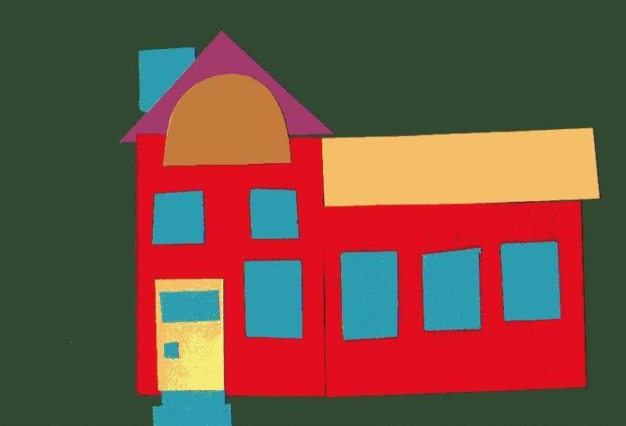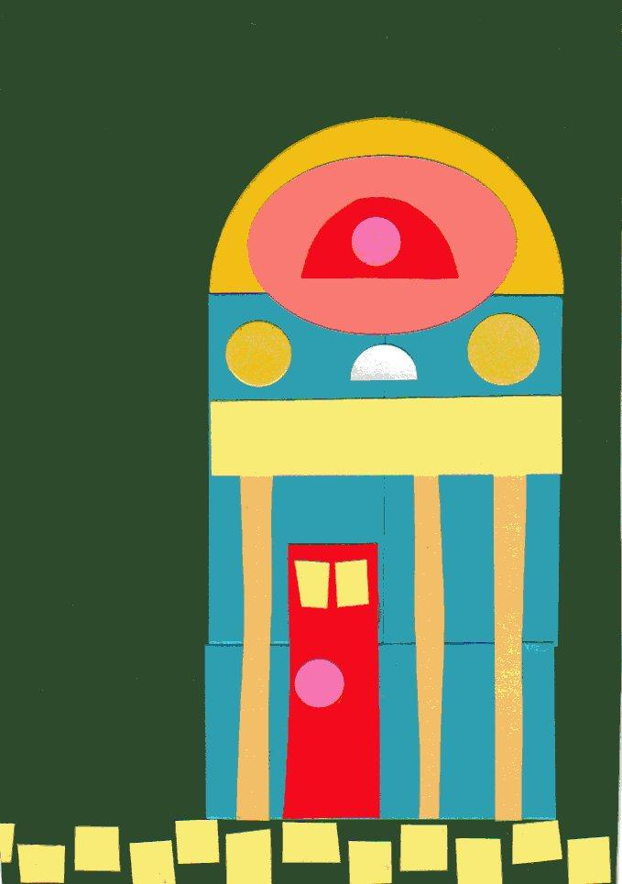
Sample Assessments

Formative
Students respond to the following questions:
What other jobs do artists have in our community?
Student shows evidence of using good craftsmanship in creating a composition.
Visual arts rubric is available on the last page of this guide.

Resources

Digital images and/or information related to architecture and Frank Gehry may be accessed at the following website:

http://www.oprf.com/flw/bio/index.html

http://bcsd.k12.ny.us/middle/hokanson/PAGES/8th%20grade/FrankLloydWrightPPT.ppt

http://www.GreatBuildings.com

http://www.artchive.com/artchive/B/brancusi.html http://en.wikipedia.org/wiki/Constantin_Brancusi
http://www.whitehutchinson.com/children/articles/playgrndkidslove.shtml

http://www.pbs.org/wnet/americanmasters/database/gehry_f.html
http://www.nypost.com/seven/06072007/news/regionalnews/designer_playground_regionalnews_david_seifman_______city_hall_bureau_chief.htm
http://www.galinsky.com/buildings/guggenheimbilbao/index.html
http://www.kid-at-art.com/htdoc/lesson12.htmlhttp://www.artjunction.org/images/paper.pdf

